10-8-2020
User Manual Web Platform | Moxzones
MOXZONES | User Manual Web Platform

Content
INTRODUCTION 2
ATLETHE MODE 3
Authentication 3
Recover password 4
Purchase of Subscription 5
Validate Order 7
Main Page of the Athlete Mode 8
Activity Detail for Basic Level 9
Activity Detail for Advanced Level 10
Account 11
Legal Information 12
COACH MODE 13
Main Page 13
Add Athlete 13
Scheduled Trainings 14
My training 16
Consultation of the trainings of the athlets 17
Delete activities of athletes 21
Monitor training 21

INTRODUCTION

This document aims to explain the functioning of the MoxZones Web Platform, as well as the profiles incorporated in both the App and the Platform.
MoxZones is a tool created mainly for athletes who want to measure and improve their performance by monitoring the SMO2 provided by devices such as Humon. The information is displayed visually and intuitively to be able to track the evolution in real time.
MoxZones also allows you to be part of a team managed by a coach, allowing the coach to track in real time, and plan focused exercises for each of the athletes.
The platform works with different subscription levels, which give you different functionalities and accesses according to the acquired subscription:
- Basic monthly
- Basic annual
- Advanced monthly
- Avanzado annual
- Coach montyly
- Coach annual
For more information please visit https://moxzones.com/subscriptions 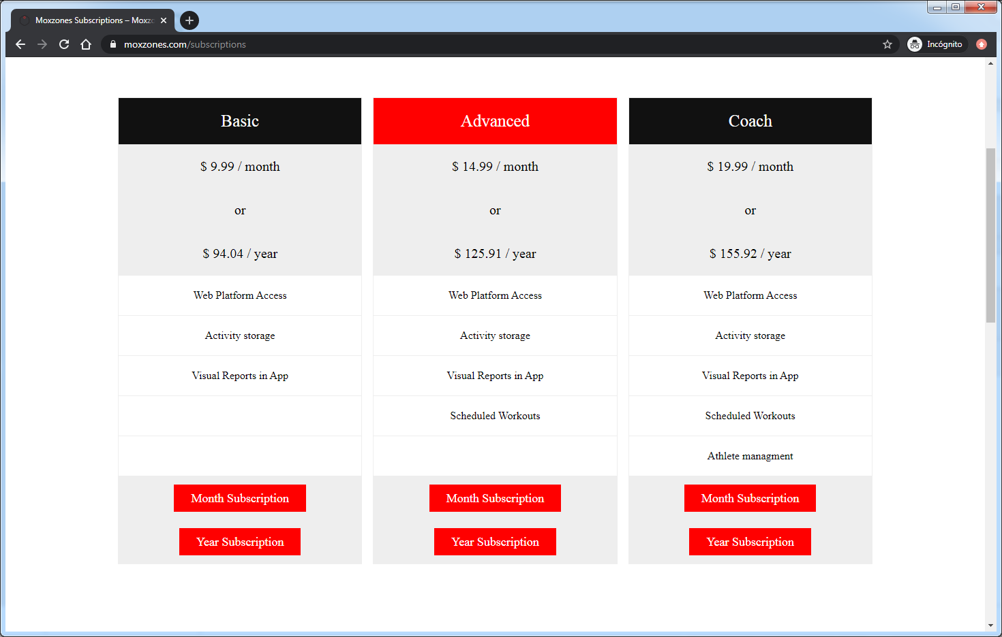
In case you do not have a subscription, you will not be able to enjoy the different benefits of the web platform.

ATLETHE MODE

Authentication

The page allows to authenticate the registered users in moxzones.com, in case of not having registered the user jet you can download the MoxZones app from GooglePlayStore and register there. Then you can pay the subscription from the subscriptions section on the web platform.
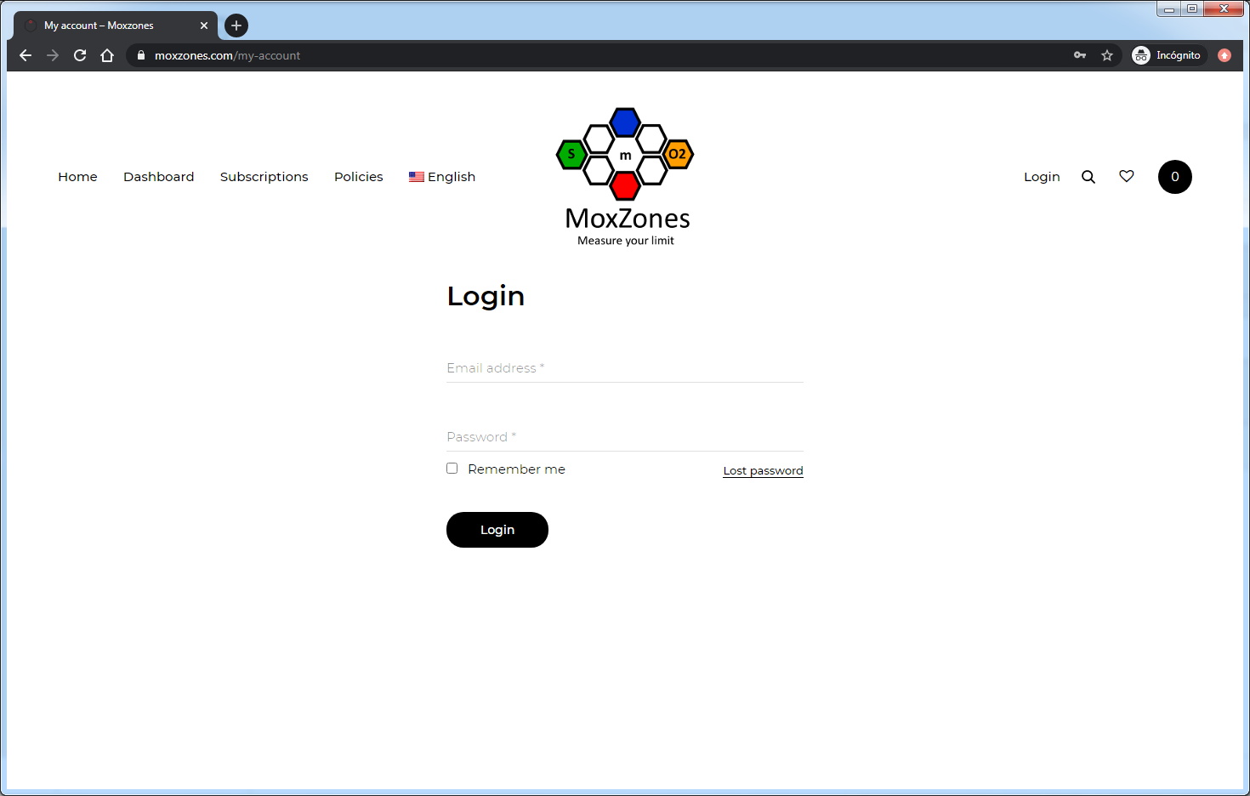

Field | Description | Required
Email or user name | Email or user name registered in moxzones | S
Password | Password to access | S
Login | Allows authentication | S
Lost Password | Shows page to recover lost password | N

Frequent mistakes:
- Incorrect entry of credentials
- Inactive User
- Subscription expired, remember to renew your subscription before it expires

Recover password

The Page allows you to enter an email, then a link will be sent to the user's email address, so that the user can generate a new password.
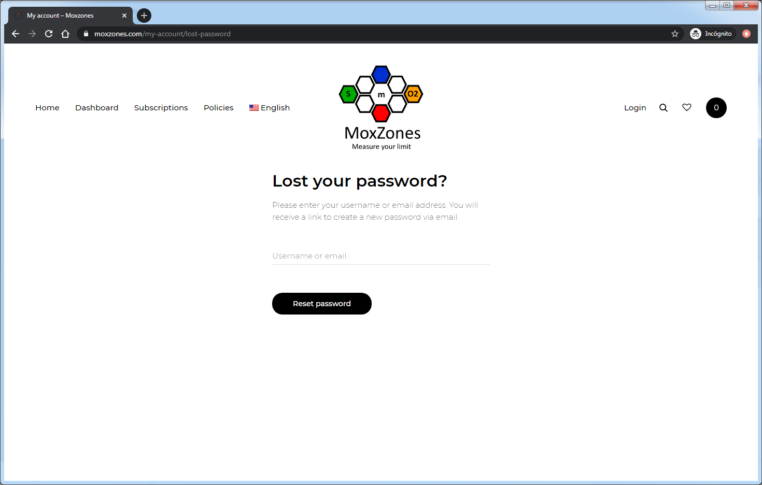
Field | Description | Required
Email | Email or user name registered in moxzones | S
Reset Password | Sends mail with new password | N

Frequent mistakes:
- Incorrect entry of email or username of the account you want to regain Access to.

Purchase of Subscription

The page allows you to buy a subscription.
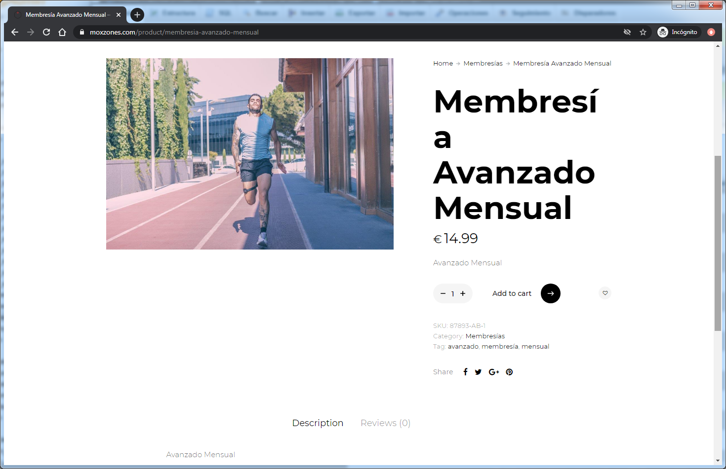
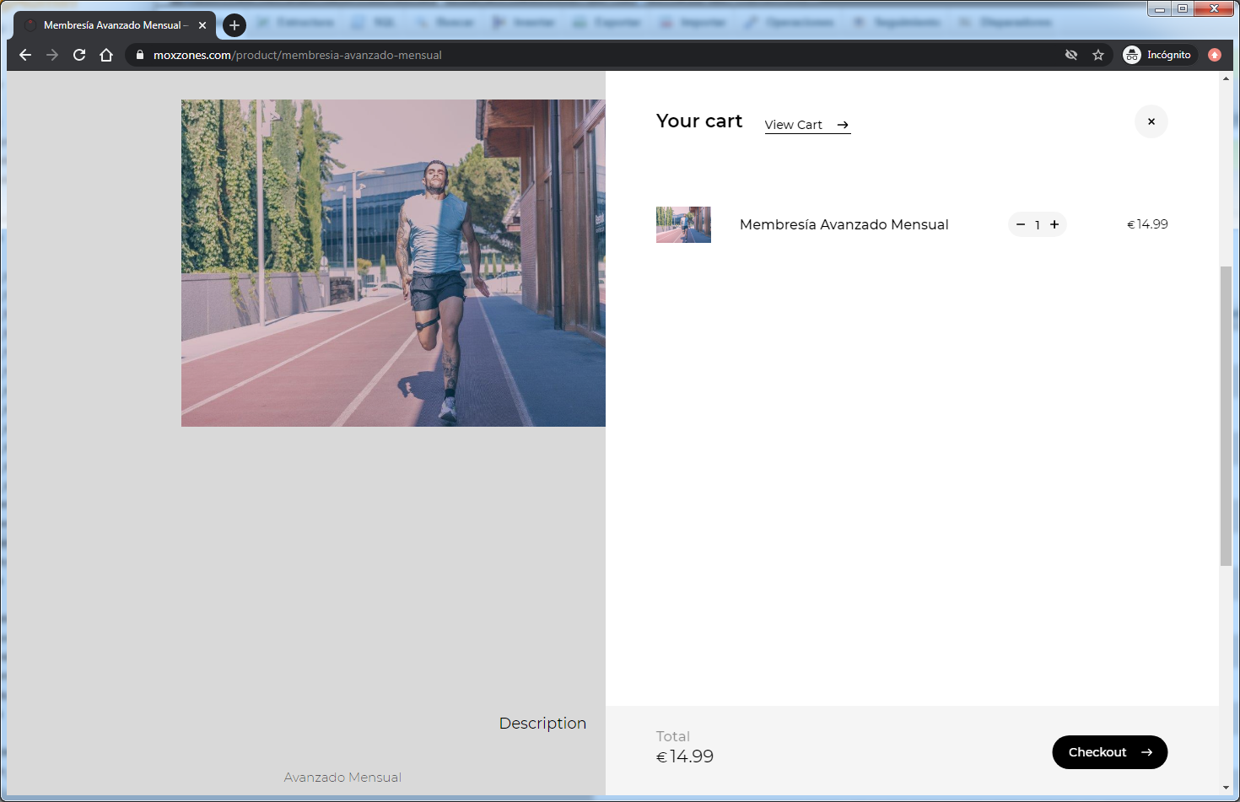
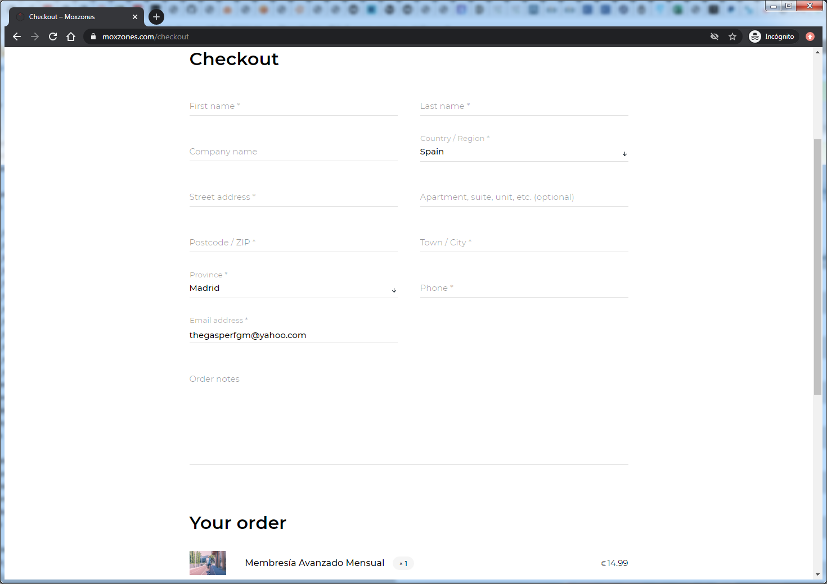
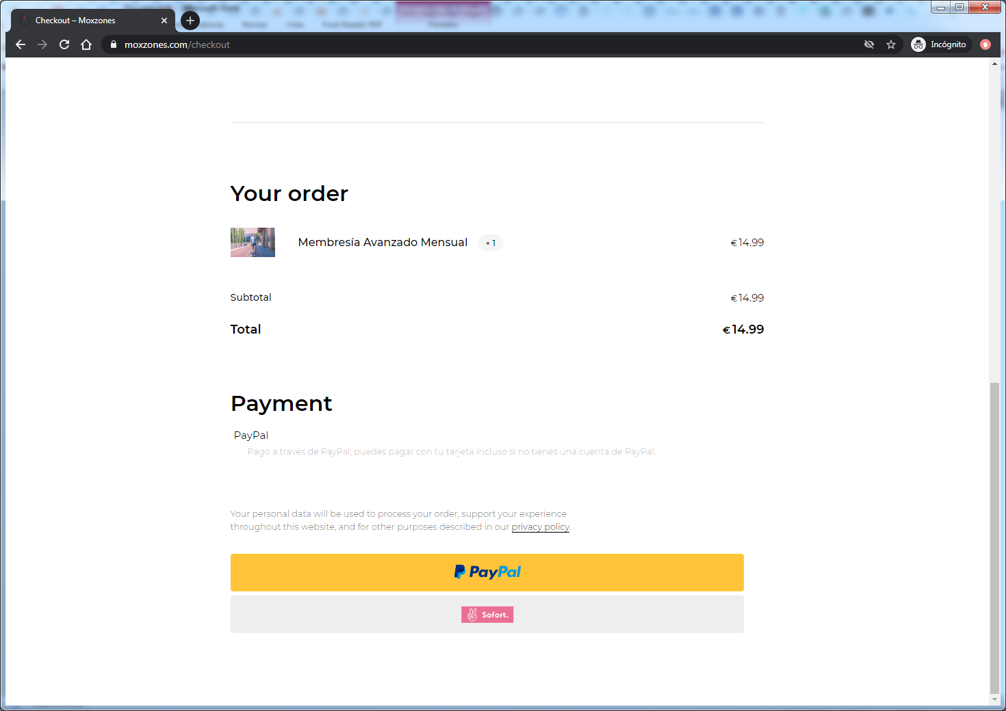
Frequent mistakes:
- We recommend to first download the app and register from there and then buy the subscription in order to speed up the accessibility of the purchased subscription.

Validate Order

After having purchased a subscription, the request will be received by our team who will inform you via email when your subscription is activated and ready to be used both in the app and on the web platform.

Main Page of the Athlete Mode

After having logged in, the main page of the web page is displayed; We can access the Dashboard, where the summary of the user's training sessions is displayed. From this page you can access and consult the different activities synchronized from the application.
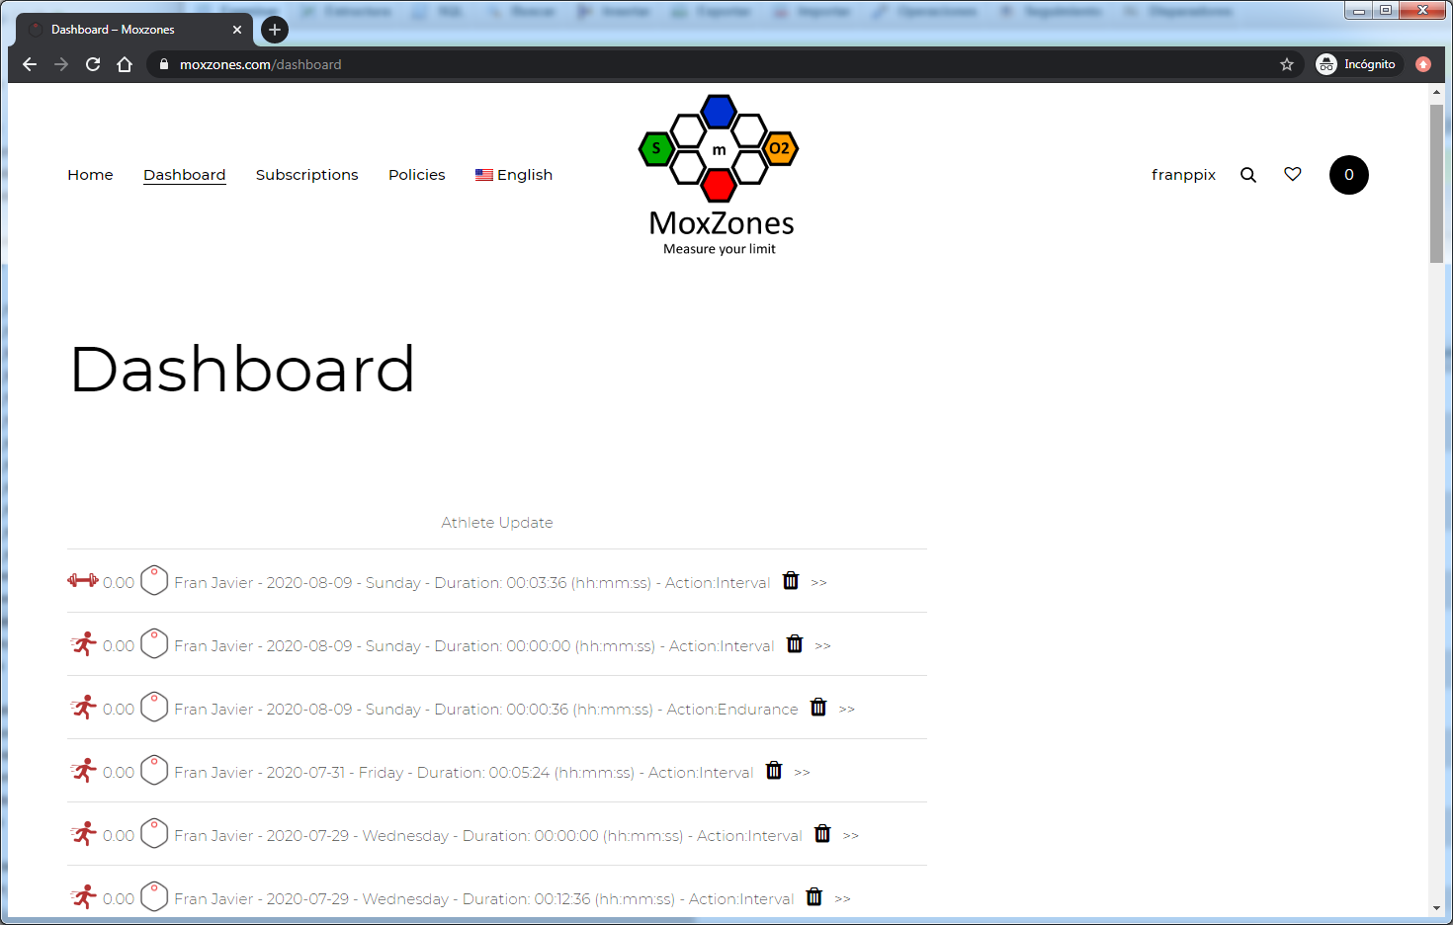
Suscripción Level
For basic level, only the query for the purchased period is shown.
For advanced level, the query of the purchased period is displayed and the CSV download of each activity is enabled by accessing the activity detail.

Activity Detail for Basic Level
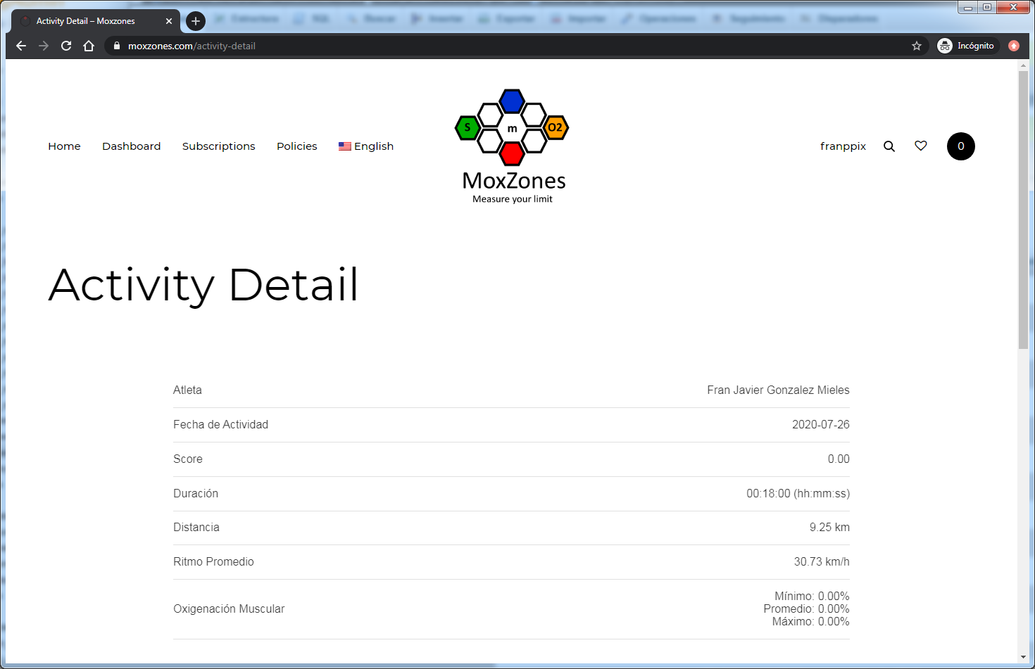
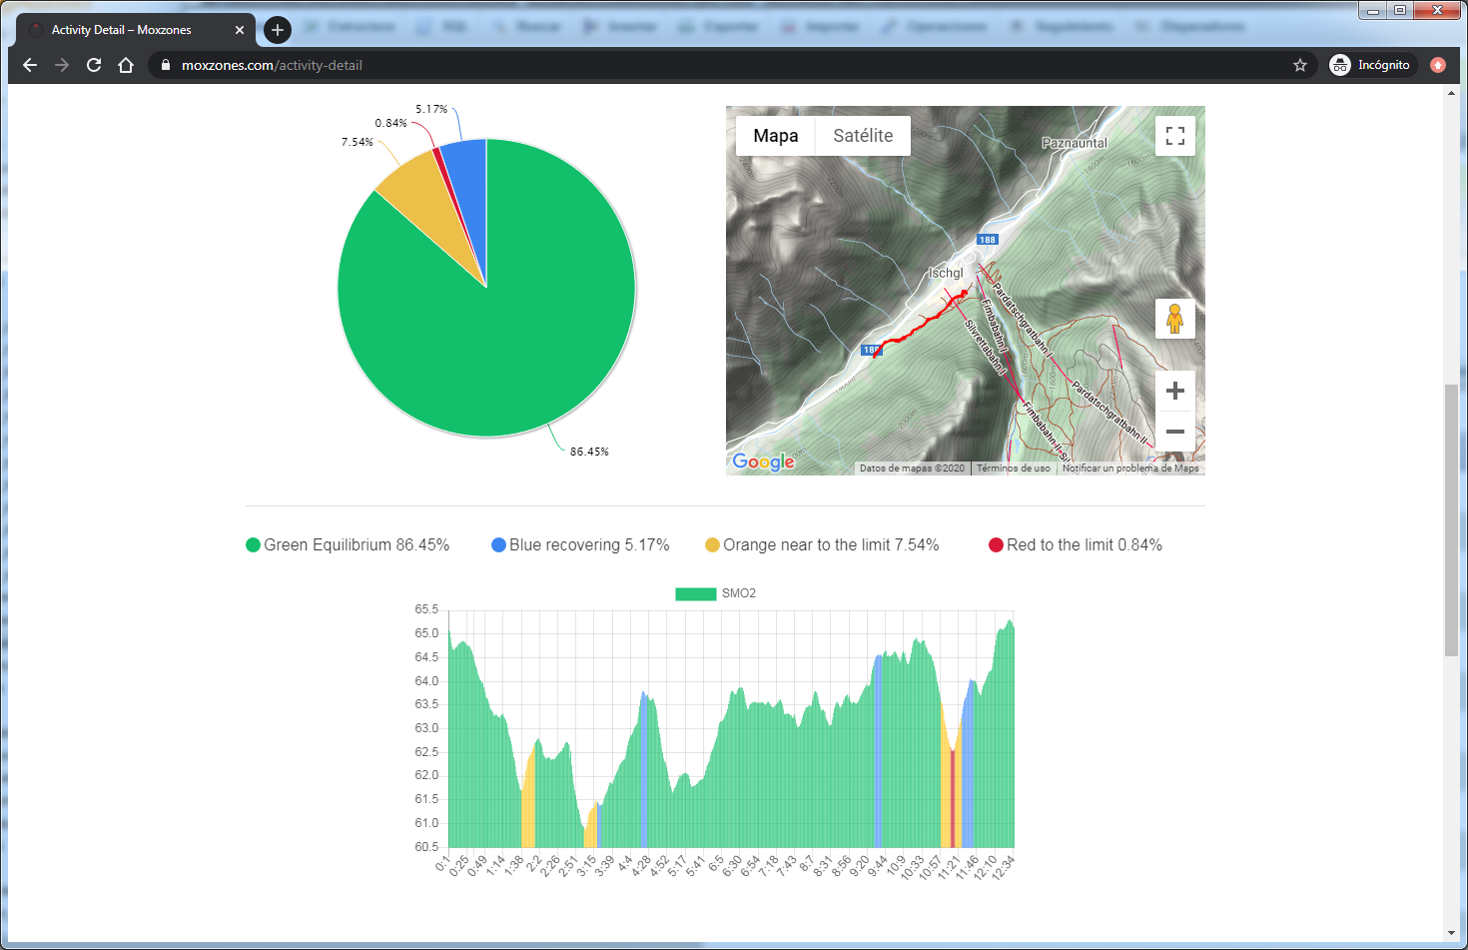
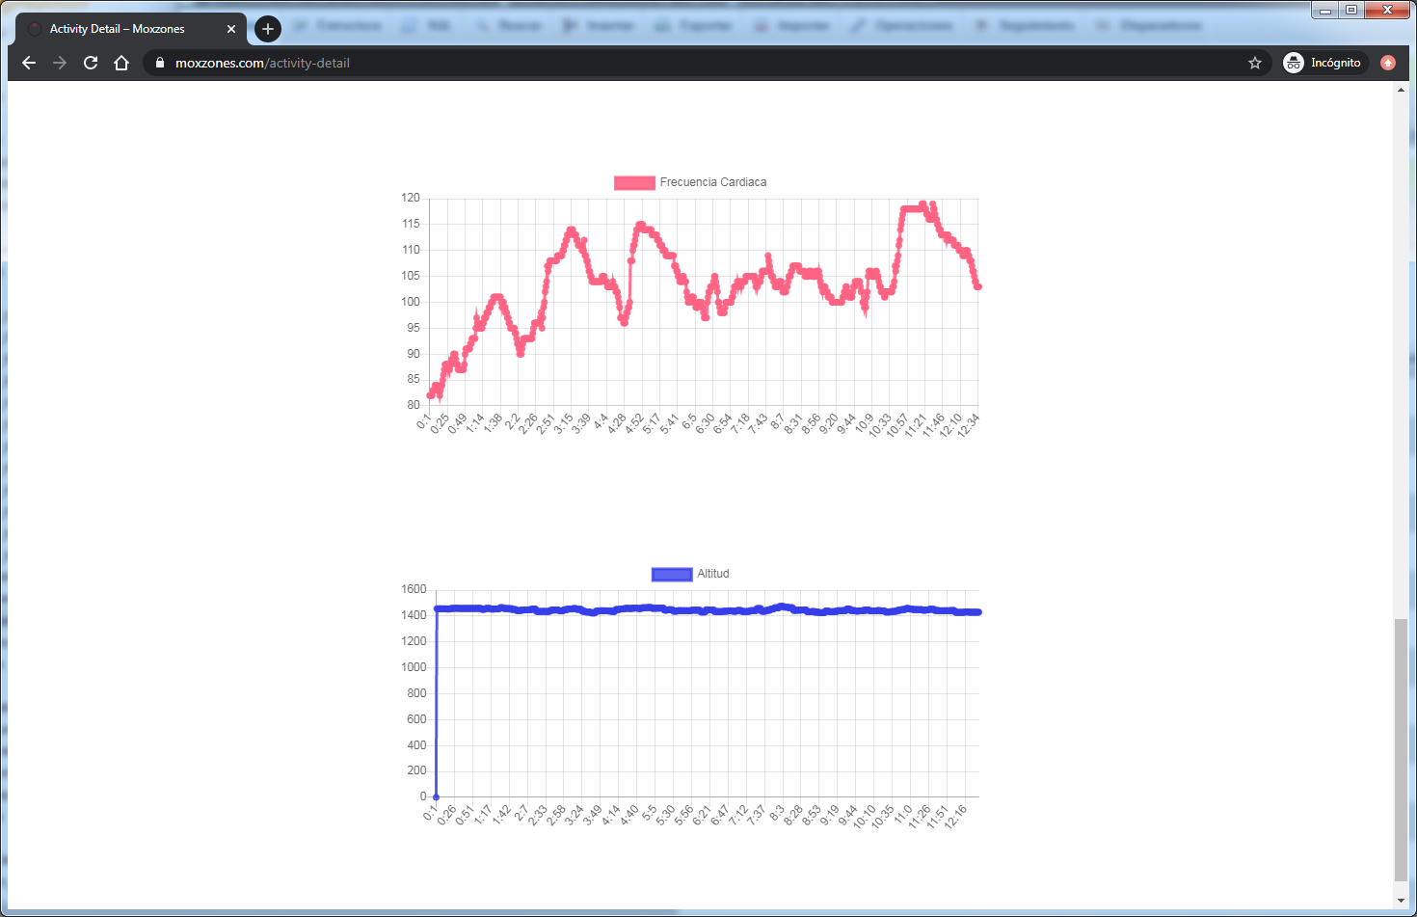

Activity Detail for Advanced Level
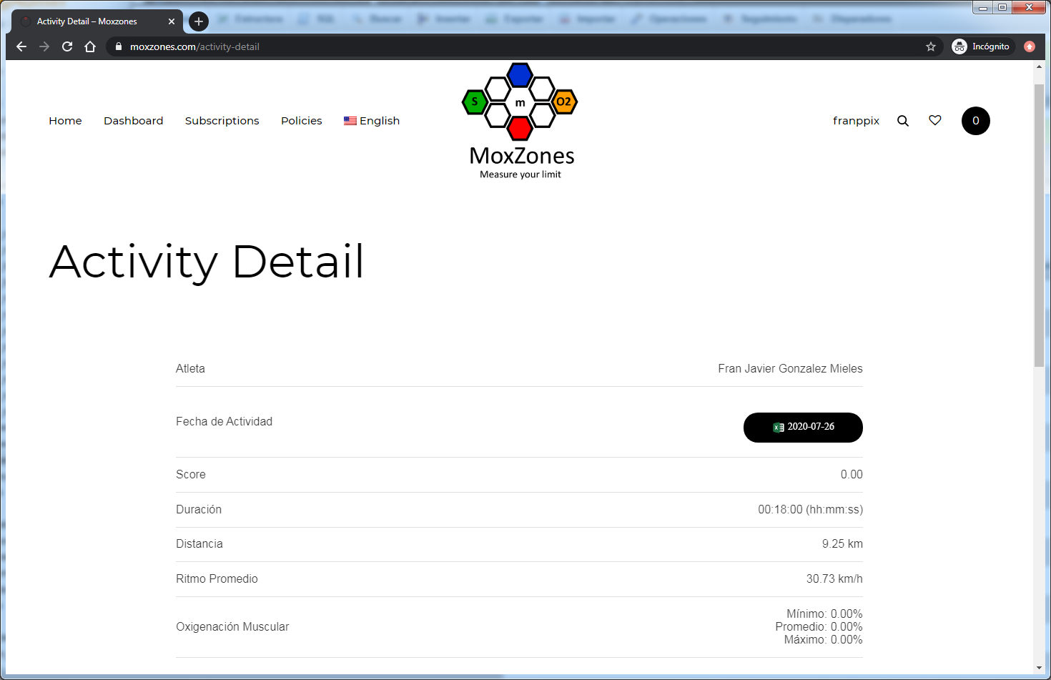

Account
This page will show the user data and the orders.
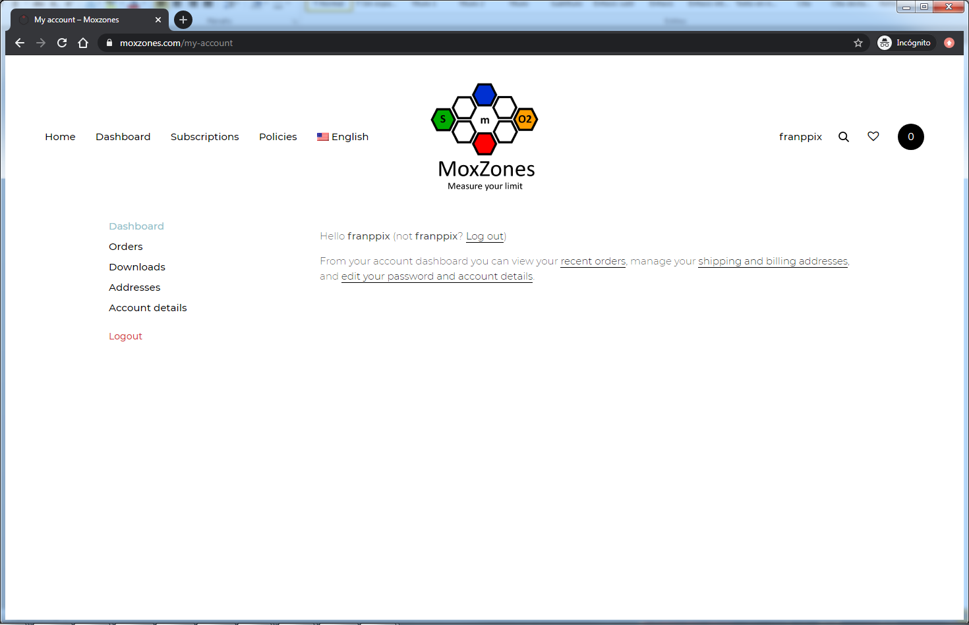

Legal Information

You can consult the legal information of our company in the Policies’ section.
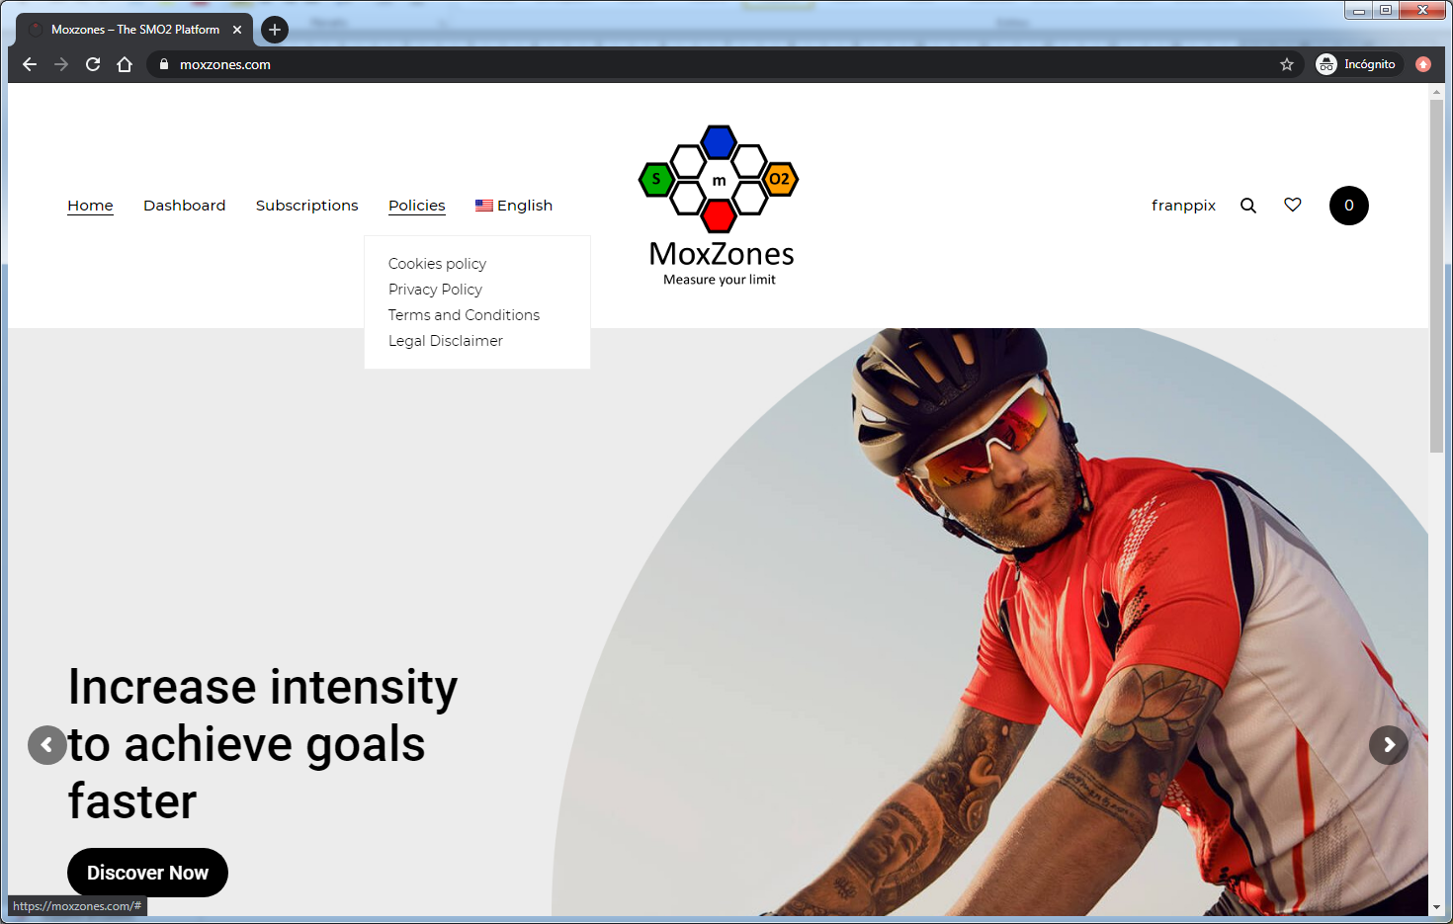

COACH MODE

Main Page

After logging in, the main page of the web platform shows the summary of team members and a list of available options for the coach mode.
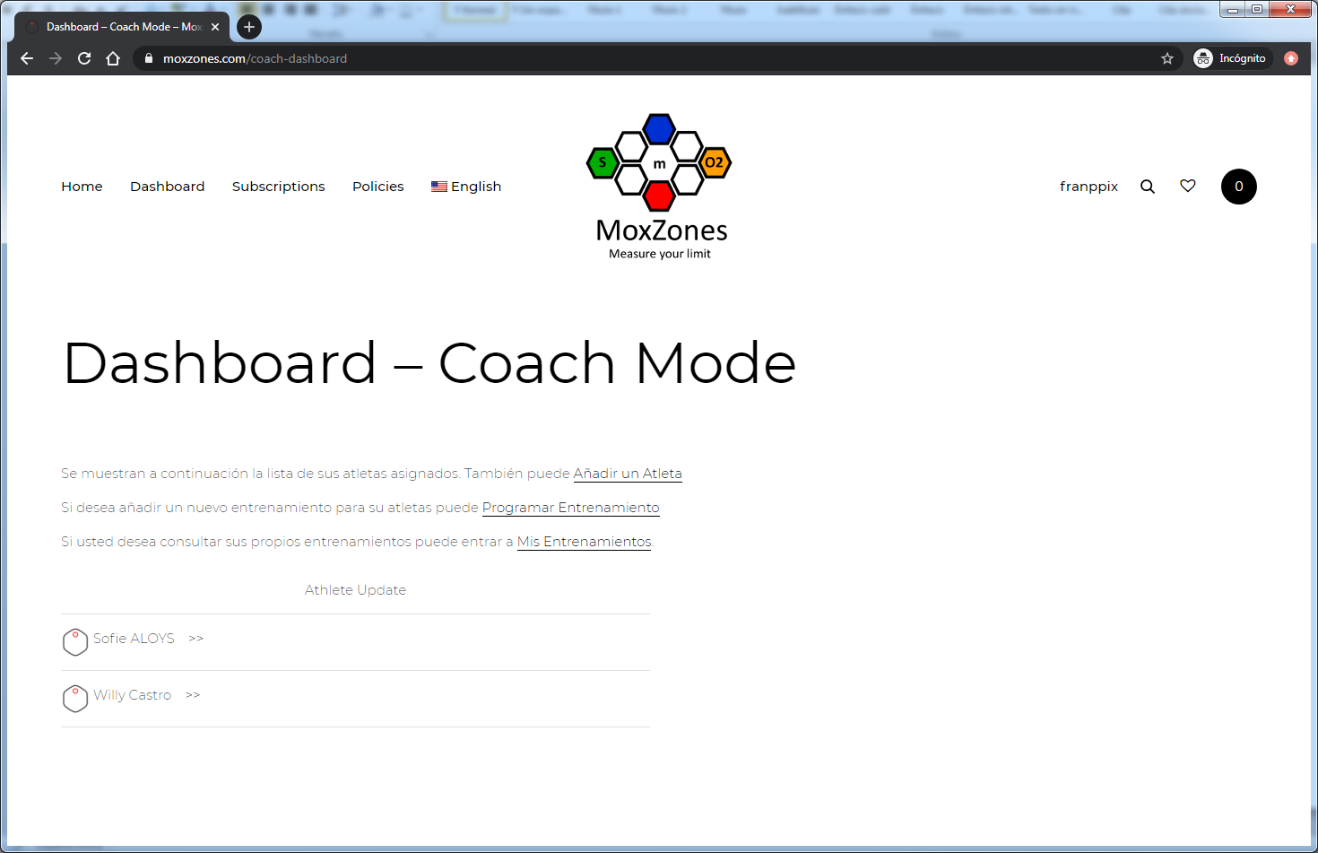
Suscripción Level
Coach

Add Athlete

This page allows you to search an athlete by email. In order to add an athlete, he/she must have an advanced type subscription.

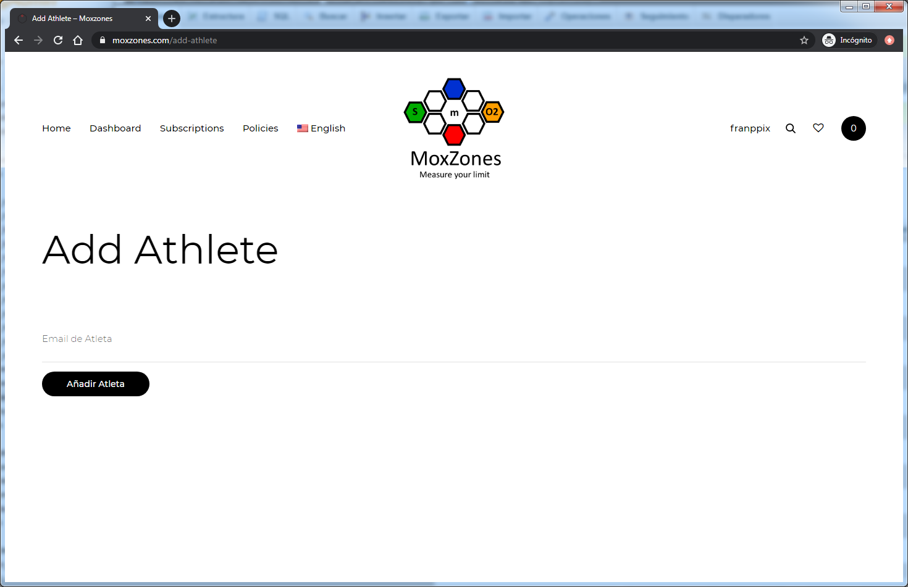
Suscripción Level
Coach only

Scheduled Trainings

Page to schedule workouts for your team. It also shows the workouts currently scheduled which you can consult or delete.
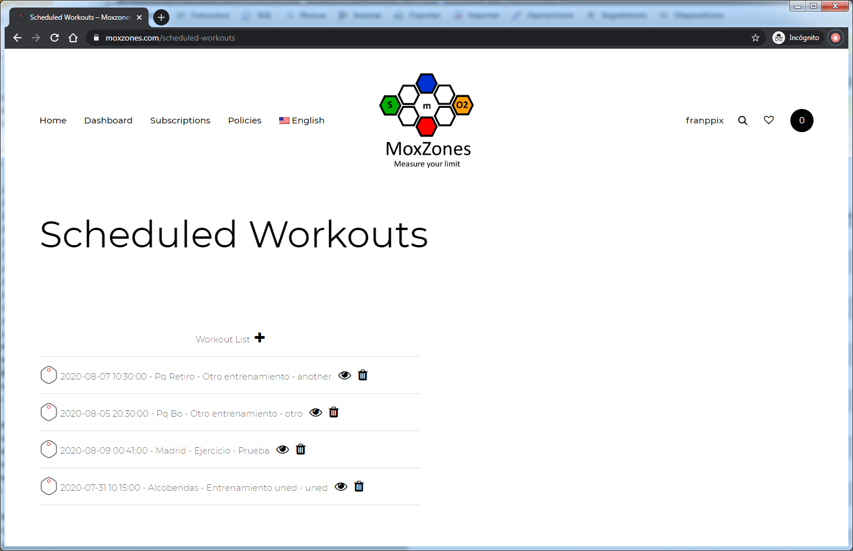
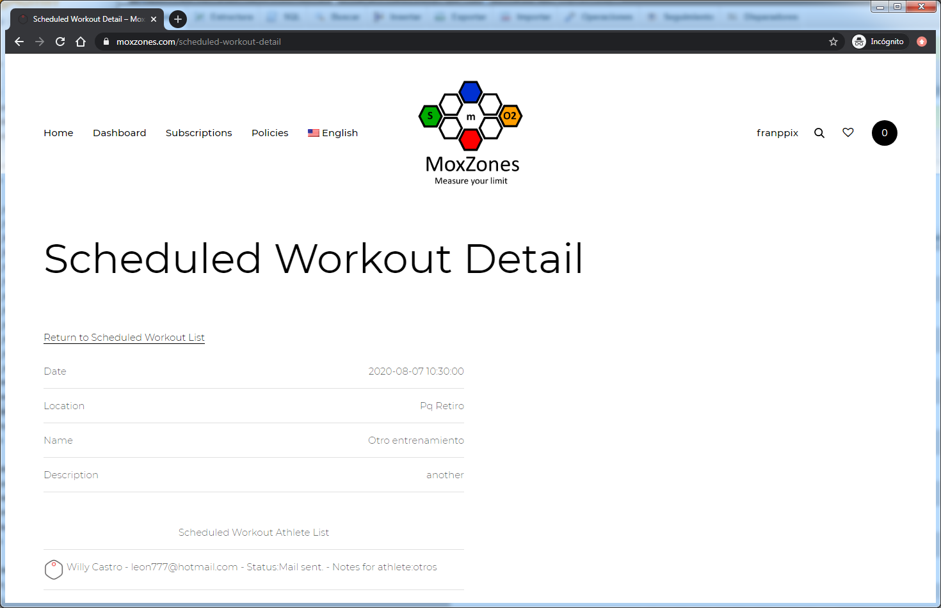
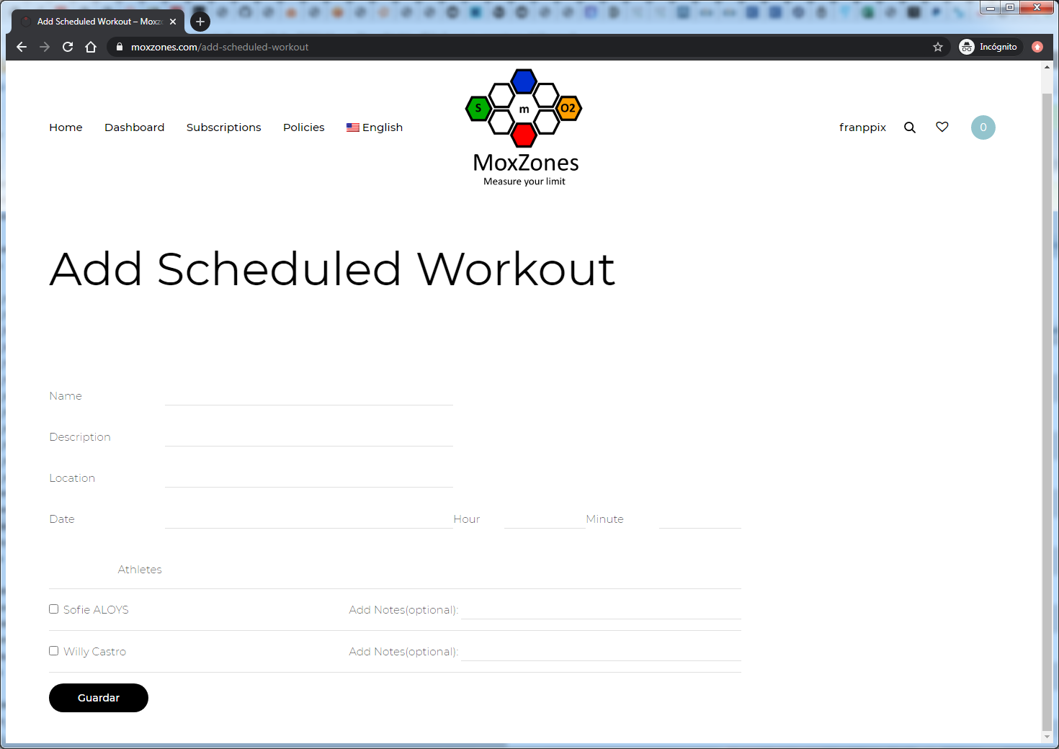
Suscripcion Level
Coach Only

My training

Page to review the coach's own trainings.
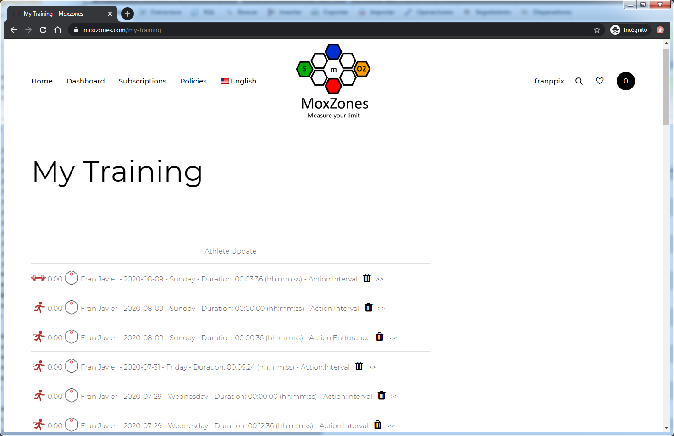
Suscripción Level
Coach Only

Consultation of the trainings of the athlets

This page allows you to consult the training sessions of a member of your team.
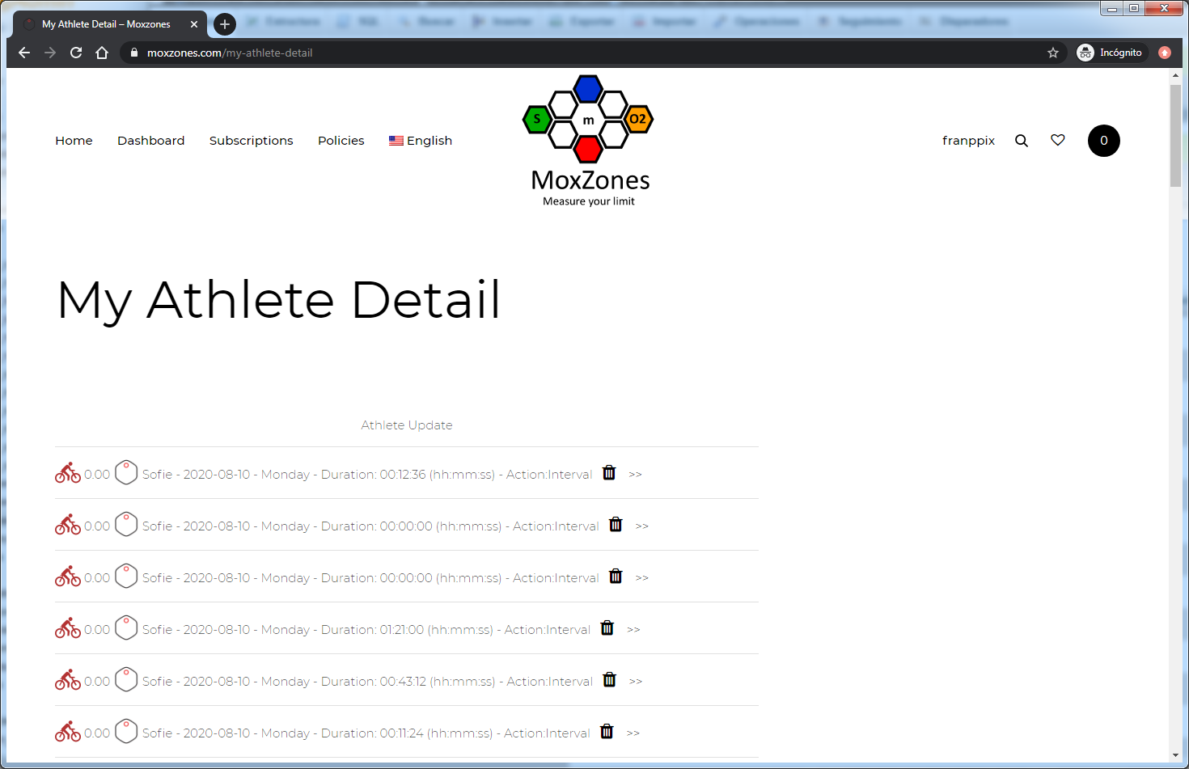
When selecting an activity, the activity detail page is displayed. If the activity is in” Real Time”, the page will be updated every 10 seconds in order to keep track of the Athlete of your team. Please bear in mind that this option is only available for the Coach mode.
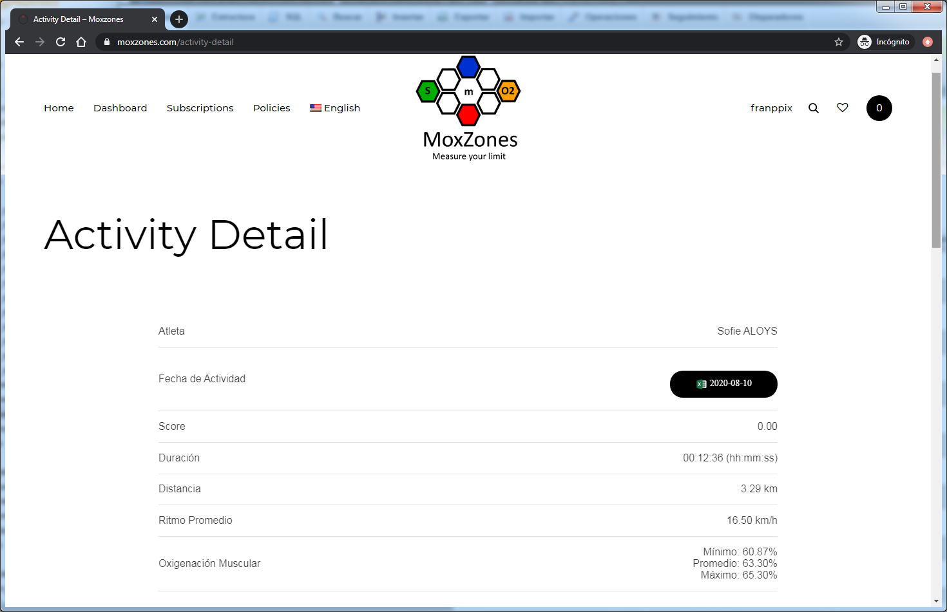

Suscripción Level
Coach Only

Delete activities of athletes

The coach can delete the activities of the athletes from his team, also each athlete can delete their own workouts from the summary of their activity.

Suscription Level
Coach Only

Monitor training

The activity detail page allows you to monitor the training if it is in real time, the information is displayed almost in real time, there is a delay of 5 to 11 seconds depending on the connection.

Suscription Level
Coach Only

